**Project Planning Phase**

**Project Planning Template (Product Backlog, Sprint Planning, Stories, Story points)**

|  |  |
| --- | --- |
| Date | 22 October 2022 |
| Team ID | PNT2022TMID48082 |
| Project Name | Project -Smart Waste Management System For Metropolitan Cities |
| Maximum Marks | 8 Marks |

**Product Backlog, Sprint Schedule, and Estimation (4 Marks)**

Use the below template to create product backlog and sprint schedule

| **Sprint** | **Functional Requirement (Epic)** | **User Story Number** | **User Story / Task** | **Story Points** | **Priority** | **Team Members** |
| --- | --- | --- | --- | --- | --- | --- |
| Sprint-1 | Create Html files | USN-1 | We use HTML to create the front end part of the web page. | 3 | High | Suryakumar,  Rahul |
| Sprint-2 | Build Python code | USN-2 | We build the flask file ‘app.py’ which is  a web framework written in python for  server-side scripting. | 4 | High | Aswinkumar,  Ravikumar |
| Sprint-2 | Run the App | USN-3 | We can run the App | 2 | Medium | Rahul,  Ravikumar |
| Sprint-3 | Register IBM Cloud | USN-4 | We can register IBM Cloud | 2 | Medium | Suryakumar,  Aswinkumar |
| Sprint-3 | Login | USN-5 | As an Administrator, I need to give user id and password for every workers over there in municipality. | 2 | High | Suryakumar |
| Sprint-3 | Login | USN-6 | As a Co-Admin, I’ll control the waste level by monitoring them via real time web portal. Once the filling will happens, I’ll notify trash truck with location of bin & their bin ID. | 1 | High | Rahul |
| Sprint-4 | Dashboard | USN-7 | As a Truck Driver, I’ll follow Co-Admin’s Instructions to reach the filled bin in short roots and saves time. | 2 | Low | Aswinkumar |
| Sprint-4 | Dashboard | USN-8 | As a Local Garbage Collector, I’II collect all the wastes from the garbage, load it onto a garbage truck, and deliver it to Landfills. | 2 | Medium | Ravikumar |
| Sprint-4 | Dashboard | USN-9 | As a Municipality officer, I'll make sure everything is proceeding as planned and without any problems. | 1 | High | Suryakumar |

**Project Tracker, Velocity & Burndown Chart: (4 Marks)**

| **Sprint** | **Total Story Points** | **Duration** | **Sprint Start Date** | **Sprint End Date (Planned)** | **Story Points Completed (as on Planned End Date)** | **Sprint Release Date (Actual)** |
| --- | --- | --- | --- | --- | --- | --- |
| Sprint-1 | 20 | 6 Days | 24 Oct 2022 | 28 Oct 2022 | 20 | 29 Oct 2022 |
| Sprint-2 | 20 | 6 Days | 31 Oct 2022 | 04 Nov 2022 | 20 | 05 Nov 2022 |
| Sprint-3 | 20 | 6 Days | 07 Nov 2022 | 11 Nov 2022 | 20 | 12 Nov 2022 |
| Sprint-4 | 20 | 6 Days | 14 Nov 2022 | 18 Nov 2022 | 20 | 19 Nov 2022 |

**Velocity:**

To calculate the team’s **average velocity (AV)** per iteration unit

**𝐴𝑣 =**  𝑉𝑒𝑙𝑜𝑐𝑖𝑡𝑦

𝑆𝑝𝑟𝑖𝑛𝑡 𝑑𝑢𝑟𝑎𝑡𝑖𝑜𝑛

Where,

**Average Velocity** - Story points per day

**Sprint duration** - Number of days (Duration) for Sprints

**Velocity** - Points per Sprint

**𝐴𝑣** = 20/5 = 4

Average Velocity is **4** points per Sprint

**Burndown Chart:**

A burn down chart is a graphical representation of work left to do versus time. It is often used in agile[software development](https://www.visual-paradigm.com/scrum/what-is-agile-software-development/) methodologies such as [Scrum](https://www.visual-paradigm.com/scrum/scrum-in-3-minutes/). However, burn down charts can be applied to any project containing measurable progress over time.

#### **Sprint 1 burndown: Sprint 2 burndown:**

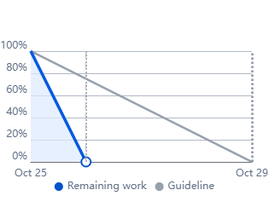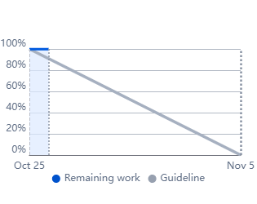

**Sprint 3 burndown: Sprint 4 burndown:**

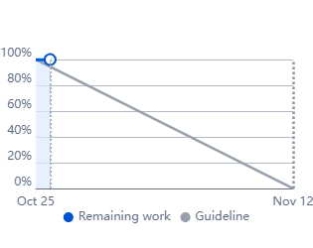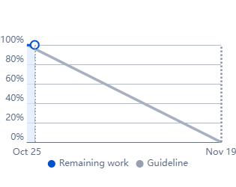

**Reference:**

**<https://www.atlassian.com/agile/project-management>**

**<https://www.atlassian.com/agile/tutorials/how-to-do-scrum-with-jira-software>**

**<https://www.atlassian.com/agile/tutorials/epics>**

**<https://www.atlassian.com/agile/tutorials/sprints>**

**<https://www.atlassian.com/agile/project-management/estimation>**

**<https://www.atlassian.com/agile/tutorials/burndown-charts>**